Buddy PPE Check

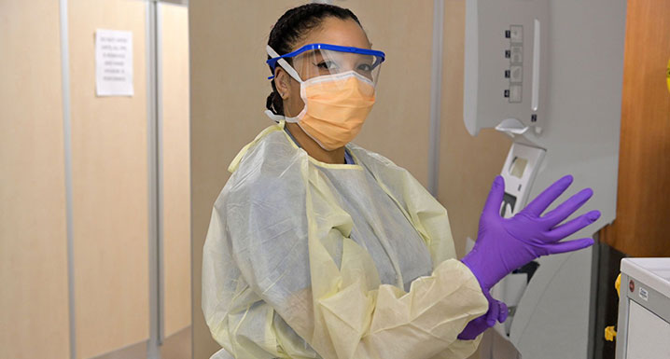

With lots going on in our day, let’s keep each other safe by doing PPE checks on each other, ensuring we are all wearing appropriate PPE.

Good times to do this are at report time and before heading into a red or orange zone room.

